Is your culture more indulgent or restrained?

- Indulgent → permissive, tending to be tolerant and generally allowing people (or self) to have what they want
- Restrained → controlled, keeping somebody or something under control or within limits

Discuss in a small group and fill in this table!
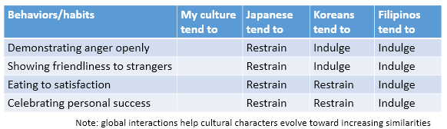

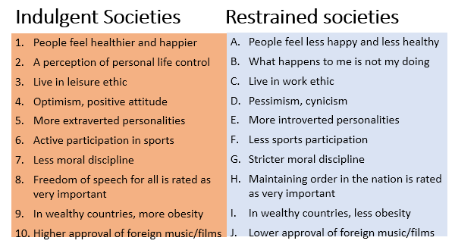
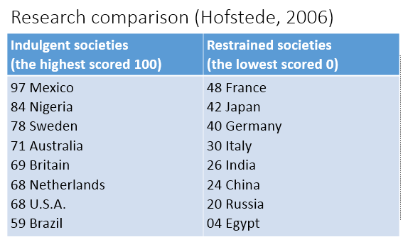
Study these quotes and share your thoughts!

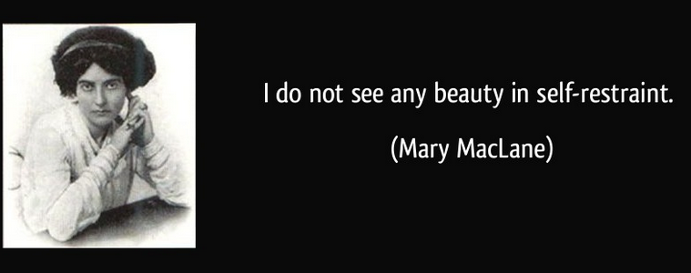

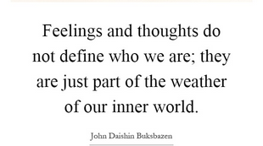

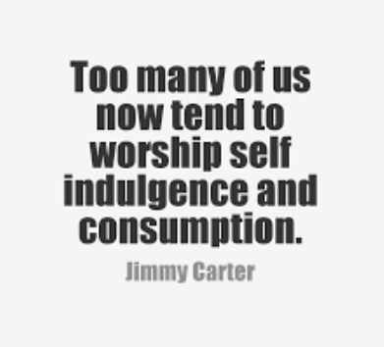

Choose one of these questions to evaluate one of the quotes above:

- In your opinion, why does this person have such opinion?
- Do you agree with his/her statement? Why?
- Is this quote useful or relevant to your culture? Please explain!

